**Participant groups will be paired with an experienced firefighter & embedded in the process for hands-on experience and Q&A.**

**YOU WILL LEARN HOW TO:**

* Construct fire lines
* Use a drip torch
* Appropriately apply the resources most ranches have on hand (e.g. UTVs, water tanks, etc.)
* Manage risk
* Scout, fire, mop and patrol burn units

**Please RSVP To:** Katie (katie@ranchadvisory.com) and Kendal (kendal@forestguild.org)

**Lodging will be available for those travelling from afar. Meals will be provided.**

**May 17th: 9am – 5pm**

**Introductory training & preparation**

**May 18th: 8am – 6pm**

**Burn Day**

**May 19th: 8am – 4pm**

**Fire Line Management &**

**Mope Up**

This is a hands-on, operational training to provide landowners with exposure to the process of responsibly implementing a prescribed burn from start to finish on private property. This workshop builds on last year’s classroom session, which introduced participants to the foundations of prescribed burning as a management tool. Attendance at last year’s workshop is not a requirement to join this workshop.

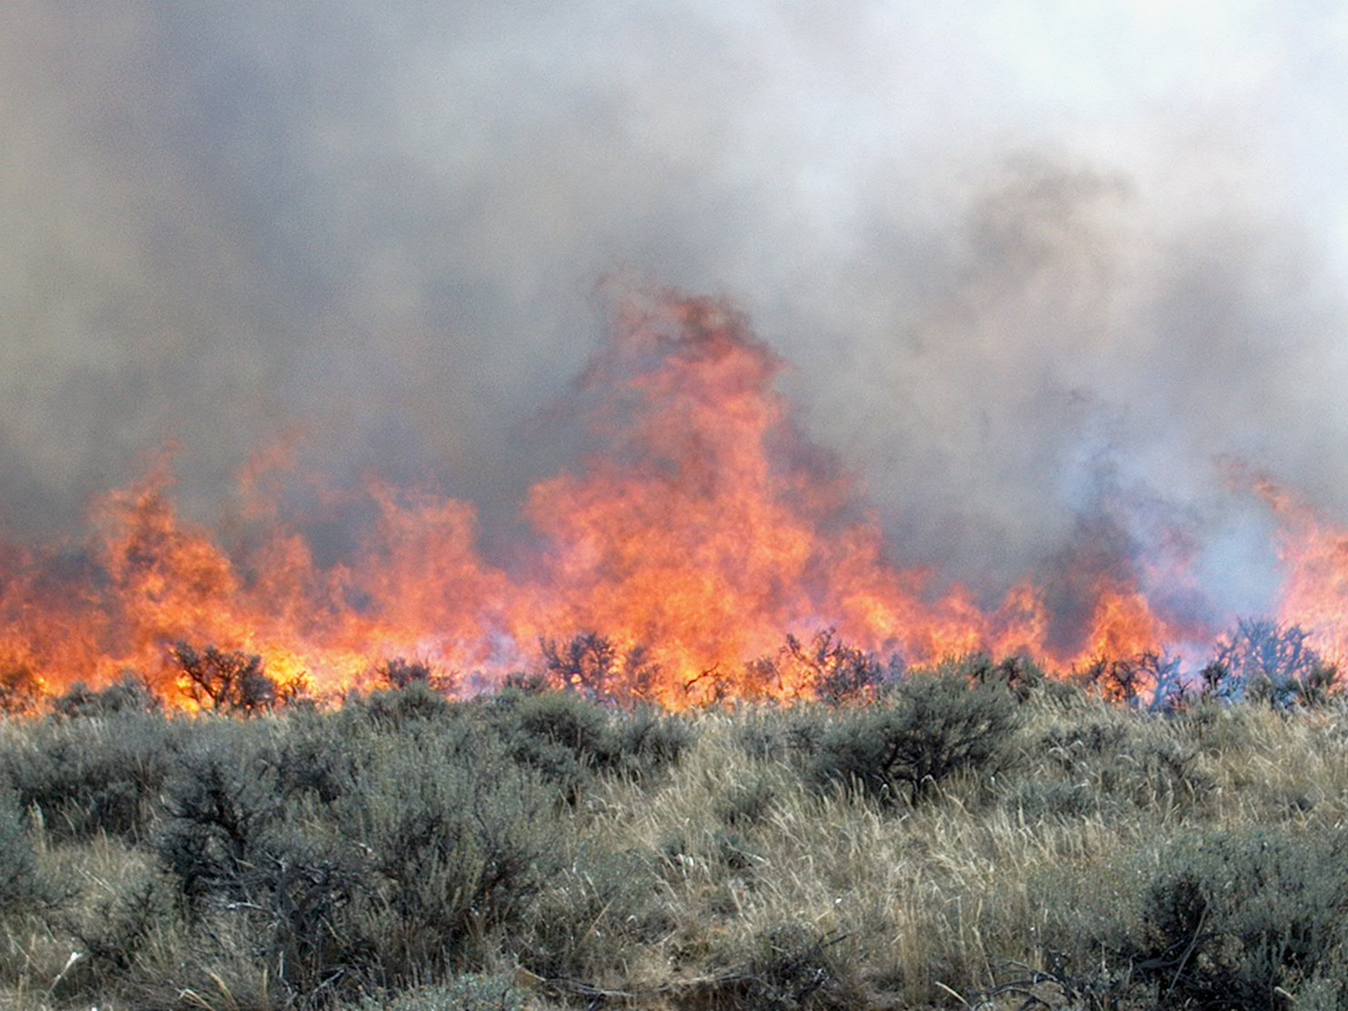

PRESCRIBED FIRE WORKSHOP

*MAY 17-19, 2019*

*FORT UNION RANCH*

*WATROUS, NM*

*JOIN THE*

*FORT UNION*

*RANCH, HIGH PLAINS GRASSLANDS ALLIANCE & FOREST STEWARDS GUILD*

