Energy Solutions Whitepaper
Submitted to the U.S. Department of Interior by the Western Landowners Alliance

Private Lands and Western Energy Development
Conventional and alternative energy development is re-shaping the western landscape, our communities, economies and private lands. Energy development can play a very positive role, boosting local economies, benefitting landowners and providing renewable resources. Unplanned energy development, however, can be devastating to community values and critical natural resources. We do not need to follow the old pattern of boom and bust in the western landscape, yet this is precisely what is happening. Coherent planning is lagging behind the new energy boom. Western Landowners Alliance is working to change this. Through the creation of the Private Lands Energy Council and the initiatives described below, we are seeking rational, measured approaches that can support current energy needs while still conserving our lands and natural resources for future generations. To achieve this, we need to find ways to work more effectively across multiple jurisdictions and particularly with the Department of the Interior. Significant planning gaps remains across public and private surface lands and mineral ownerships. We commend the Department’s recent efforts to improve landscape-scale planning and conservation and offer the following perspectives and initiatives from the private lands side to support reform.

Collaborative Planning and Communication
We frequently hear calls for balance and protection of natural resources in the energy development debates. To achieve this, we need better communication and better planning with broader and earlier stakeholder involvement.

Based on actual experiences of our landowner members and partners, we have identified the following as areas in which significant improvements can be made in the planning, communication and development process:

- What might be termed an upside-down approach. The development of energy resources is prioritized in federal land use planning. On the private side, the mineral estate is legally dominant over the surface estate. Because of this, energy development starts with plans to maximize exploitation of the resource and subsequently develops environmental assessments and strategies to mitigate resulting impacts. This fundamentally undermines the concept of landscape-level planning. If real balance is sought, it must be prioritized from the outset and maintained throughout the planning process. This requires improved and meaningful stakeholder participation from the earliest planning stages. The three initiatives by private land entities below demonstrate real-world efforts to achieve this kind of balance.

- No comprehensive planning for the development of non-federal mineral interests. For a number of legal, economic and political reasons, there are few mechanisms to provide landscape-scale planning for energy development of non-federal mineral interests. As a result, the development of privately held mineral interests is uncoordinated and can result in unnecessary adverse impacts and a loss of potential economic benefits. In fact, mineral lease terms often prohibit mineral owners and surface owners from communicating with one another about their developments. Further, competition between private interests and between public and private interests to develop the resource can drive development in ways rational planning may not support.
- Inadequate planning in split-estate contexts. Because federal planning jurisdiction is largely limited to federal surface lands and because local land use planning often does not address energy development, projects on split-estate parcels are not governed by adequate landscape-scale planning. Instead, individual projects are evaluated on a case-by-case basis through the environmental assessment process with limited public participation. These assessments are often done without the benefit of even a field visit and are in many cases blind to a wide range of non-federal land use, natural resource and economic considerations.
- Planning and environmental assessment on the federal side. Initial, project level planning is typically led by industry with little agency involvement. Following that is the agency environmental assessment process, which has little public involvement until the review process. The review takes place last in the process, after significant effort and expense by industry who then are heavily invested in a given outcome, and after considerable work in the development of environmental documentation by regulatory agencies. The planning and assessment processes are compartmentalized and limiting in terms of the free flow of information and broader participation. Given these circumstances it is understandable that such a situation is conducive to entrenchment of positions by industry, skepticism by the public, and challenges to the agencies, all of which lead to contention, delays, and needless expense.

Successful Models
Members of the Western Landowners Alliance are actively involved in three areas of work, which in combination, provide promising opportunity for simple, yet effective reforms.

The format of this submittal is intentionally brief and therefore provides an encapsulated description of these three successful working relationships and processes. It is however adequate to demonstrate the value of these models and to provide the basis for further dialogue with DOI regarding their broader application and the promise they hold in the identification of solutions for more efficient and responsible energy development. They include three case studies, two of which involve landscape-scale planning, and a third, that focuses on project implementation strategies.

It is our belief that a broad-based, landscape-scale planning effort should be an initial step in the energy development process. The DOI 2010 Lease Reforms and Master Lease Planning (MLP) are important steps in this regard. We encourage broader and meaningful implementation of the MLP reforms. In addition, we offer two case studies of compatible approaches designed to improve landscape-scale planning process and broad-based participation.

Case Study 1 – Community Values Analysis.
A specific model for early, broad-based participation in the energy development process is being implemented in Rio Arriba and Archuleta Counties in New Mexico and Colorado by the Chama Peak Land Alliance, previously chaired by WLA’s executive director. To help communities proactively and constructively engage in energy planning, a unique partnership of counties and non-governmental organizations conducted a community-based mapping process to identify critical community resources such as municipal water supplies, high-value recreation, hunting areas, agricultural production areas, and other important community values that may be impacted by development.

The goal was to create a basis for landscape-scale planning that incorporates important community values in need of protection in order to lead to better planning outcomes from a variety of perspectives. It was a transparent and interactive community-driven planning and mapping exercise that identified and ranked community values on the landscape. This GIS-based map of community values can then be integrated with other data layers such as wildlife habitat and local government land use plans to create a basis for landscape-scale energy planning.

The effort was not advocating for or against energy development, but was assisting the community in gaining an informed understanding as the basis for thoughtful planning for energy development that is likely to take place in the future. Thus, this model process provides a conduit for communication and information to private land owners, local agencies, NGOs, and the public at large, in advance of any detailed investment by industry or expended effort by regulatory agencies. In fact, it provides useful advanced information for industry, regulatory agencies and local government, who are often responsible for roads, emergency services, housing issues, etc. that result from energy development.

To watch a 3-minute motion story on the process, please visit
http://youtu.be/Ta4P6sXWVbc

Case Study 2 – Collaborative Project Planning
In 2011, the High Lonesome Ranch (HLR) and the Theodore Roosevelt Conservation
Partnership (TRCP) forged a unique partnership to establish a pilot demonstration project with the objective of developing a model for responsible energy development at the landscape scale. The HLR, located in northwestern Colorado, contains a combination of deeded and leased acreage, currently under mineral lease. A working group has been assembled comprised of local, state and federal agency representatives, private land interests, and industry.

The goals of this program include:

1) Provide a real-world example of how development can be done differently to prevent the major loss of habitat and biodiversity and employ scientific approaches to wildlife management and mitigation.
2) Reduce conflict, build local partnerships, change policy, and export our success.

The group is working in a highly collaborative manner to identify both known and potential environmental issues and begin to address them through advance planning and study. As a result of having all parties at the table, techniques and solutions acceptable to all parties can be developed, with the multiple objectives of reducing environmental conflicts and assuring an efficient and timely permitting process. In such a model, communication and creativity work to a strong advantage in overcoming the costly, protracted, and contentious process that too often characterizes energy development projects in the west.

Case Study 3 – Implementation Strategies
The third area where WLA members are active in ground-breaking approaches to energy development is in advancing best management practices or BMPs. Truly state of the art techniques have been developed and implemented in two ranches managed by WLA members underlain by coal-bed methane reserves. On the Vermejo Ranch in northern New Mexico the minerals were in a split estate. Nevertheless, the ranch owners were able to work in cooperation with the developer to implement a range of techniques that protected resource values important to the surface owners. On the Tercio Ranch in southern Colorado the minerals and surface are in common ownership. Here the owner had complete control and served as the developer following an intense two-year planning effort that both addressed environmental sensitivities and created efficiencies to development. Both developments have been widely recognized as innovative projects, convincingly demonstrating that sensitive environmental values can be protected, and even enhanced, in the process of developing energy resources.

An Approach
While each of the three initiatives briefly described above has been shown to have a meaningful role in facilitating responsible energy development, we believe that in concert, they have significant promise in overcoming many of the problematic issues currently encountered in energy development in the west, and are therefore worthy of broader consideration. The following diagram illustrates how they might work together to change the energy development dynamic in positive ways that benefit private land owners, agency interests, NGOs, and industry alike.

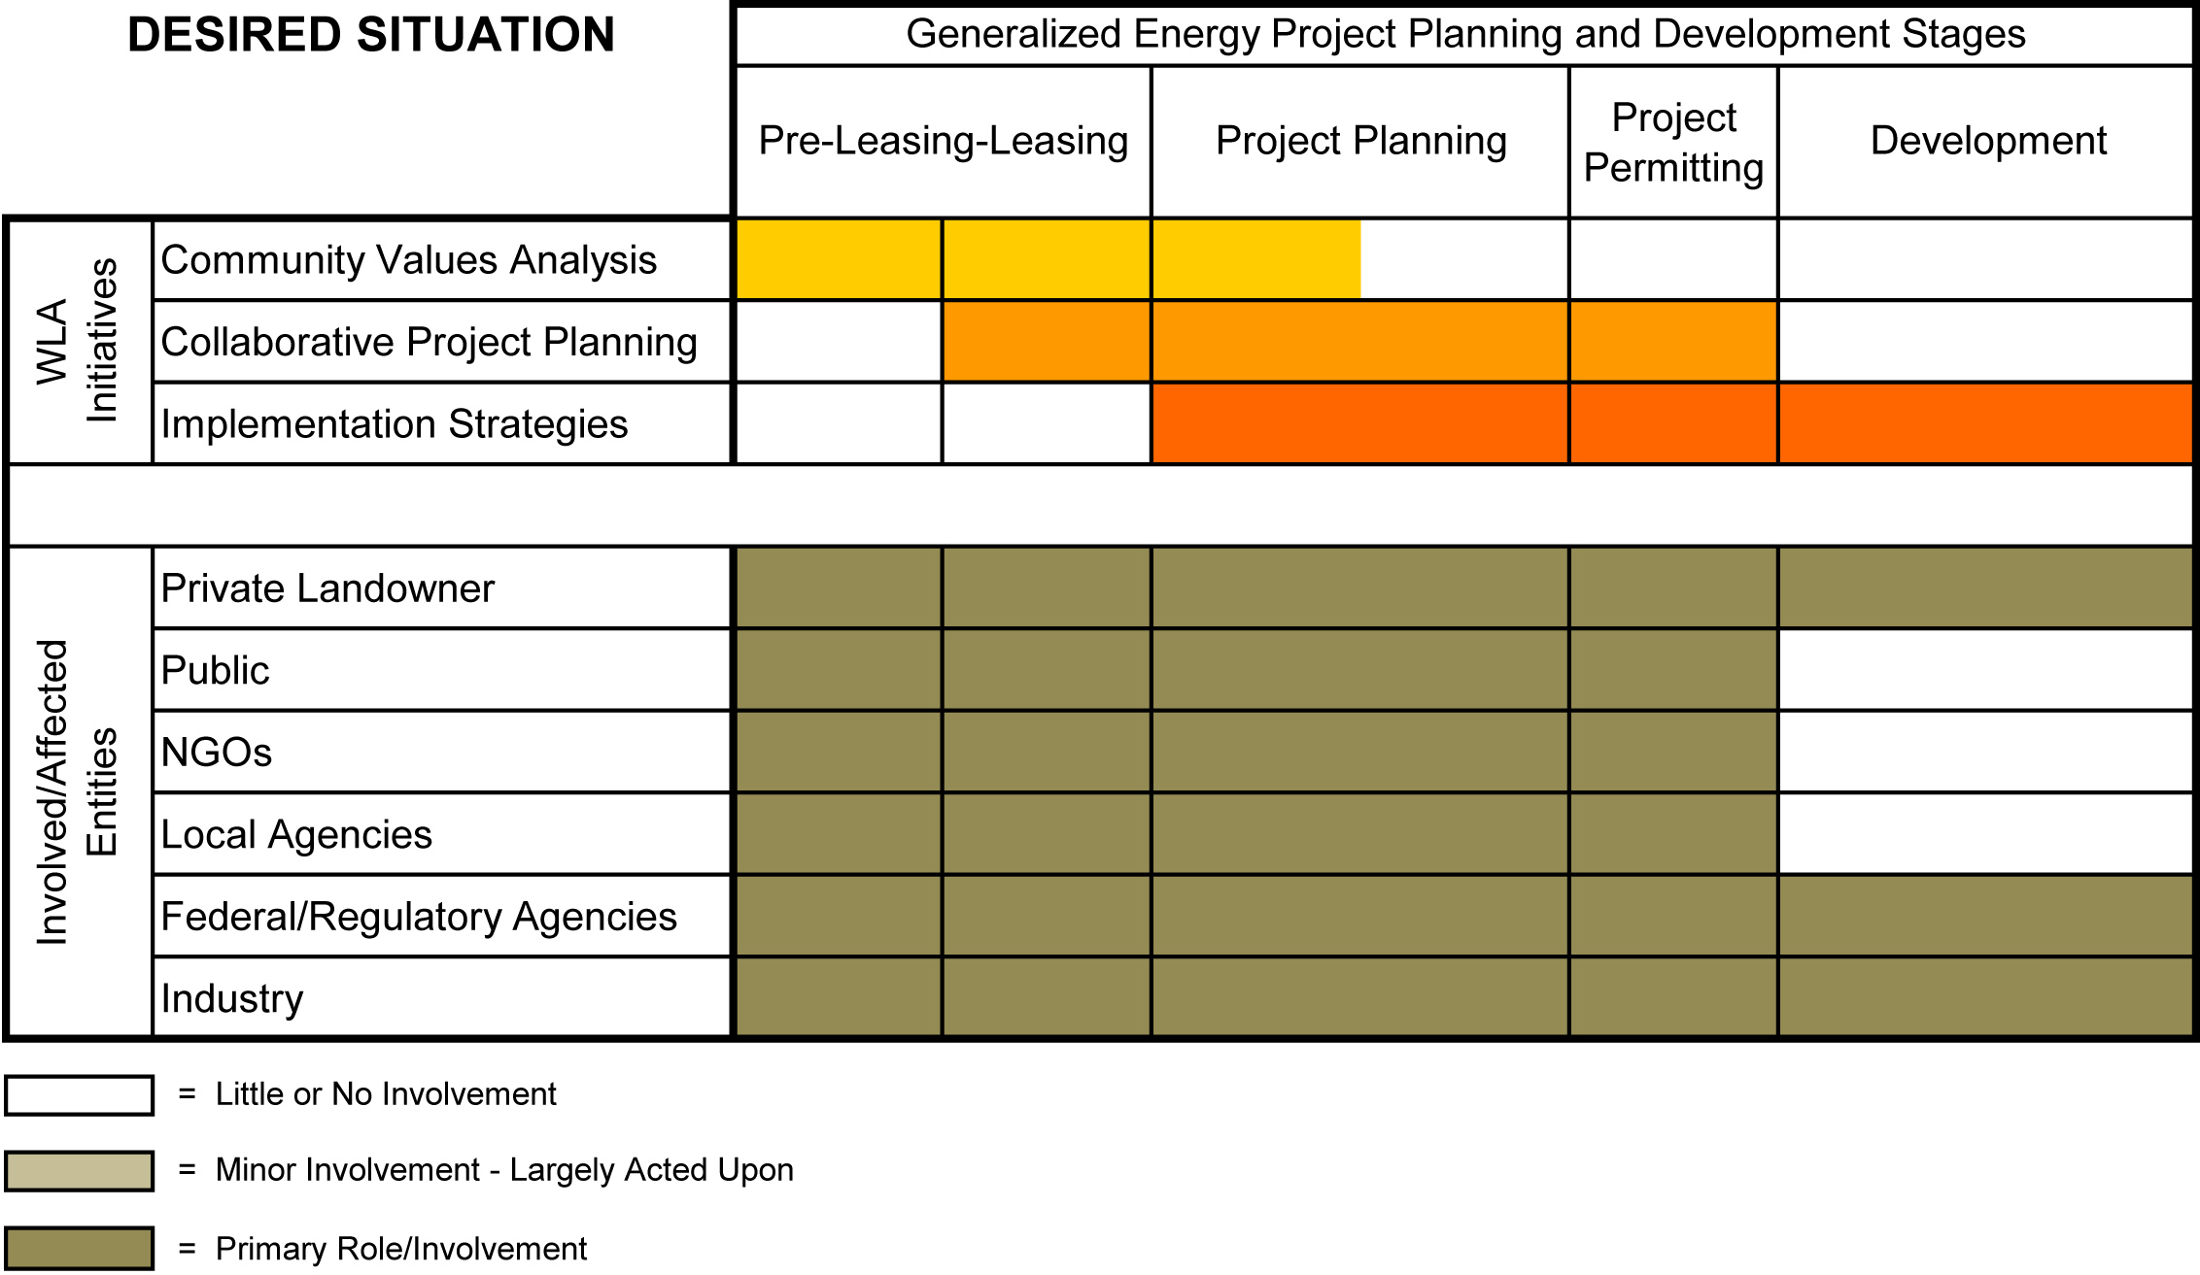

Identification of important community values during the preleasing and leasing phases of development provides a process and forum for all interested parties to participate in identifying
environmental sensitivities and important values in that community. This process thereby also identifies areas where community values are less sensitive or absent, thus creating opportunity areas where development may be more intensively concentrated. Similar to the Master Leasing Program, this early identification and awareness should be useful to industry in informing their planning in ways that avoids the common problem of investing in expensive project development planning in the absence of such understanding, and often leading to conflicts later in the process.

The collaborative project planning process being implemented at the High Lonesome Ranch is designed to facilitate the leasing through permitting phase of development. Through the more in-depth and open identification of environmental sensitivities and studies that need to accompany them, all parties, including industry, can have a voice in the creation of solutions that avoid significant environmental and land use conflicts. Thus, a very significant distinction can be achieved between the common practice wherein industry invests significant effort and resources in developing plans in isolation that then may unknowingly create environmental impacts that must then be mitigated, to the proactive avoidance of these environmental conflicts through early identification and an open and informed planning process. Such a process should then have benefits in reducing the often protracted permitting process where these conflicts often first come to light.

The third component, implementation strategies, is useful in the planning through development process where innovation and creativity can play a significant role in both avoiding potential impacts as well as reducing those that cannot be fully avoided. To bring the needed level of creativity to the process, it is important not only to investigate the kinds of innovative techniques used on the Vermejo and Tercio Ranches and other well planed and implemented projects, but to include individuals knowledgeable in both environmental sciences and the design arts, particularly landscape architects. This puts a solutions based perspective up front in the planning process and provides the expertise necessary for its successful implementation through the development phase of the project.

As an organization of conservation minded landowners who have been active in the arena of energy development, we understand that “responsible energy development” need not be merely an elusive tag line but can be a reality in practice. To this end, the Western Landowners Alliance has developed the Private Lands Energy Council. This council is tasked to develop improved frameworks, tools and resources to assist landowners, communities and public agencies in addressing energy development on private and leased public lands. The goal is to close the planning gap for energy development between federal and non-federal lands, create greater balance between energy development and other natural resources, minimize adverse impacts to private lands, and reduce conflict. We invite the Department of Interior to collaborate with us in this effort.

